Data and methodology :
1.Data description :
Two comparative studies have been published in 2024 and 2025 referring to a larger number of frameworks, 40 for the first study, 14 for the second one (Becker & alii, 2024; Nicolajsen &
alii, 2025). Some of these frameworks are mainly disclosure guidelines, and other are focused
on countries. If we consider the corporate assessment framework with disclosed data on a
reasonable number of companies (over 100), we then restrict the number of assessed
methodologies to three of them: CA100+, TPI and ACT.
All the providers in our sample are widely recognized and used by sustainable finance professionals and frequent use in academic studies. Some datasets are publicly available others were obtained by reaching out to the providers and requesting access to the ratings, the underlying indicators and documentation or information about aggregation rules and measurement protocols.
CA100+ compiles data on 170 entities. Its Disclosure Assessment framework consists of 11 indicators covering specific thematic areas. These are further broken down into sub-indicators and metrics. Each metric is represented by two columns: the first captures the ordinal categorical score, while the second indicates whether progress has been achieved since October 2024. Scores range from "Yes" (meets criteria) and "Partial" (meets some criteria) to "No" (does not meet criteria) or "Not applicable / Not assessed." Given the ordinal nature of these data, we applied a Polychoric PCA rather than a standard PCA (details are provided later in this paper). We then projected the Climate Policy Alignment and Climate Accounting & Audit dataset as supplementary variables onto the extracted factors to determine whether the accounting dimension overlaps with any latent dimensions captured by the core rating, or if it represents a blind spot in the benchmark.

TPI assesses 1,972 companies using a dual dataset: Management Quality (MQ) and Carbon Performance (CP). As noted in the TPI documentation, these metrics are complementary and should be analyzed jointly to accurately assess a company's transition progress, however our study focuses mainly on MQ. The cumulative nature of the MQ framework—where a Level 3 firm has necessarily fulfilled all requirements for Levels 0, 1, and 2—induces significant multicollinearity between questions, rendering standard Principal Component Analysis (PCA) unsuitable. Consequently, three alternative specifications are tested: the official TPI Level (aggregate score), a synthetic mean score derived from the 23 questions, and success rates per level (L0 to L5), which capture progression without redundancy. Similar to our treatment of CA100+, CP variables are treated as supplementary to determine if they overlap with the latent dimensions of the MQ score.

Finally, the ACT dataset assesses 437 companies, providing an overall score, a Narrative score, a Trend score, and 9 granular indicator scores, along with sector-specific weights. We perform a PCA on these 9 indicator scores: (1) Targets, (2) Material Investment, (3) Intangible Investment, (4) Sold Product Performance, (5) Management, (6) Supplier Engagement, (7) Client Engagement, (8) Policy Engagement, and (9) Business Model. We then include Narrative and Trend as illustrative variables, employing a Factor Analysis of Mixed Data (FAMD) rather than a standard PCA to account for their qualitative nature.

Regarding the base year of the analysis, while the TPI and CA100+ distributions reflect the most recent 2025 data, the ACT modules provide a snapshot from the 2024 biennial cycle. The temporal misalignment between the datasets, due to differing publication cycles, is unlikely to significantly distort the comparative analysis of the agencies' underlying methodologies. This is mainly because climate strategies and capital expenditure plans are multi-year commitments that exhibit significant stability over short-term periods.

2.Sample Overview:
Table 1 presents the descriptive statistics for the sample. These metrics provide an initial overview of the scores distributions across the three agencies before proceeding to the multivariate analysis.
CA 100+ Disclosure Assessment. | Yes | Partial | No | Not assessed
Indic 1. Net-zero GHG Emissions By 2050(Or Sooner) Ambition | 47.5% | 21.3% | 23.5% | 0.0%
Indic 2. Long-term (2036-2050) GHG Reduction Target(s | 38.4% | 42.1% | 19.5% | 0.0%
Indic 3. Medium-term (2027-2035) GHG Reduction Target(s) | 20.7% | 64.6% | 14.6% | 0.0%
Indic 4. Short-term (Up To 2026) GHG Reduction Target(s) | 9.8% | 39.0% | 51.2% | 0.0%
Indic 5. Decarbonization Strategy | 3.0% | 65.9% | 31.1% | 0.0%
Indic 6.Capital Allocation | 3.7% | 50.0% | 46.3% | 0.0%
Indic 7. Climate Policy Engagement | 7.9% | 22.0% | 70.1% | 0.0%
Indic 8. Climate Governance | 3.0% | 90.9% | 6.1% | 0.0%
Indic 9. Just Transition | 0.6% | 52.4% | 47.0% | 0.0%
Indic 10. TCFD Disclosure | 47.0% | 43.3% | 9.8% | 0.0%
Indic 11. Historical GHG Emissions Reductions [Beta Indicator in 2023]. | 8.5% | 72.0% | 18.9% | 0.6%

Table 2: TPI MQ sample overview and levels breakdown
 | YES | NO | Not Applicable
Q1L0|Does the company acknowledge climate change as a significant issue for the business? | 99.6% | 0.4% | -
Q2L1|Does the company recognise climate change as a relevant risk and/or opportunity for the business? | 91.7% | 8.3% | -
-Q3L1|Does the company have a policy (or equivalent) commitment to action on climate change? | 84.7% | 15.3%
Q4L2|Has the company set greenhouse gas emission reduction targets? | 94.2% | 5.8%
Q5L2|Has the company published information on its Scope 1 and 2 greenhouse gas emissions? | 85.6% | 14.4%
Q6L3|Has the company nominated a board member or board committee with explicit responsibility for oversight of the climate change policy? | 75.9% | 15.7%
Q7L3|Has the company set quantitative targets for reducing its greenhouse gas emissions? | 70.0% | 30.0%
Q8L3|Does the company report on Scope 3 emissions? | 80.7% | 19.3%
Q9L3|Has the company had its operational (Scope 1 and/or 2) greenhouse gas emissions data verified? | 13.2% | 9.6%
Q10L3|Does the company support domestic and international efforts to mitigate climate change? | 81.7% | 18.3%
Q11L3|Does the company have a process to manage climate-related risks? | 54.9% | 45.1%
Q12L3|Does the company disclose materially important Scope 3 emissions? | 47.2% | 52.8%
Q13L4|Has the company set long-term quantitative targets for reducing its greenhouse gas emissions? | 57.8% | 42.2%
Q14L4|Does the company's remuneration for senior executives incorporate climate change performance? | 35.5% | 64.5%
Q15L4|Does the company incorporate climate change risks and opportunities in their strategy? | 62.8% | 38.2%
Q16L4|Does the company undertake climate scenario planning? | 13.2% | 86.8%
Q17L4|Does the company disclose an internal price of carbon? | 19.4% | 80.6%
Q18L4|Does the company disclose the actions necessary to meet its emissions-reduction targets? | 5.6% | 94.4%
Q19L5|Does the company quantify the key elements of its emissions reduction strategy and the proportional impact of each action in achieving its targets? | 6.4% | 93.6%
Q20L5|Does the company's transition plan clarify the role that will be played by offsets and/or negative emissions technologies? | 8.6% | 91.4%
Q21L5|Does the company commit to phasing out capital expenditure on carbon intensive assets or products? | - | - | -
Q22L5|Does the company align future capital expenditures with its long-term decarbonization goals and disclose how the alignment is determined? | - | - | -
Q23L5|Does the company ensure consistency between its climate change policy and the positions taken by trade associations of which it is a member?-- | - | - | -
-Q1L0|Does the company acknowledge climate change as a s-significant issue for the business? | - | - | -

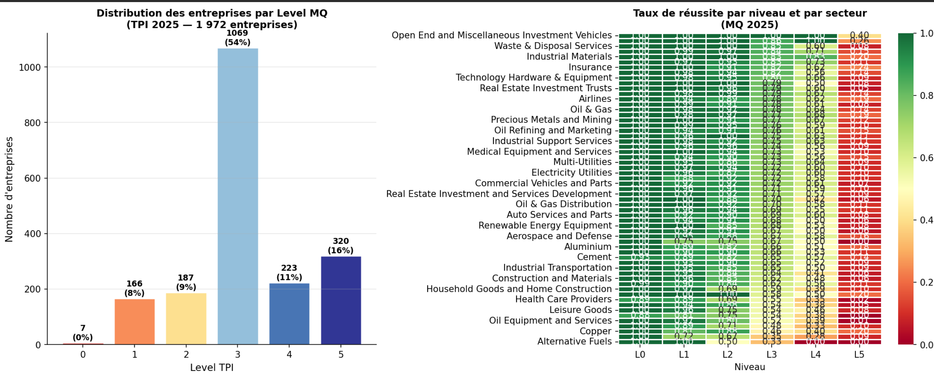
Table 3: ACT sample score overview and indicators breakdown, presented in plots.
ACT consists of three main scores, overall score Trend and Narrative.
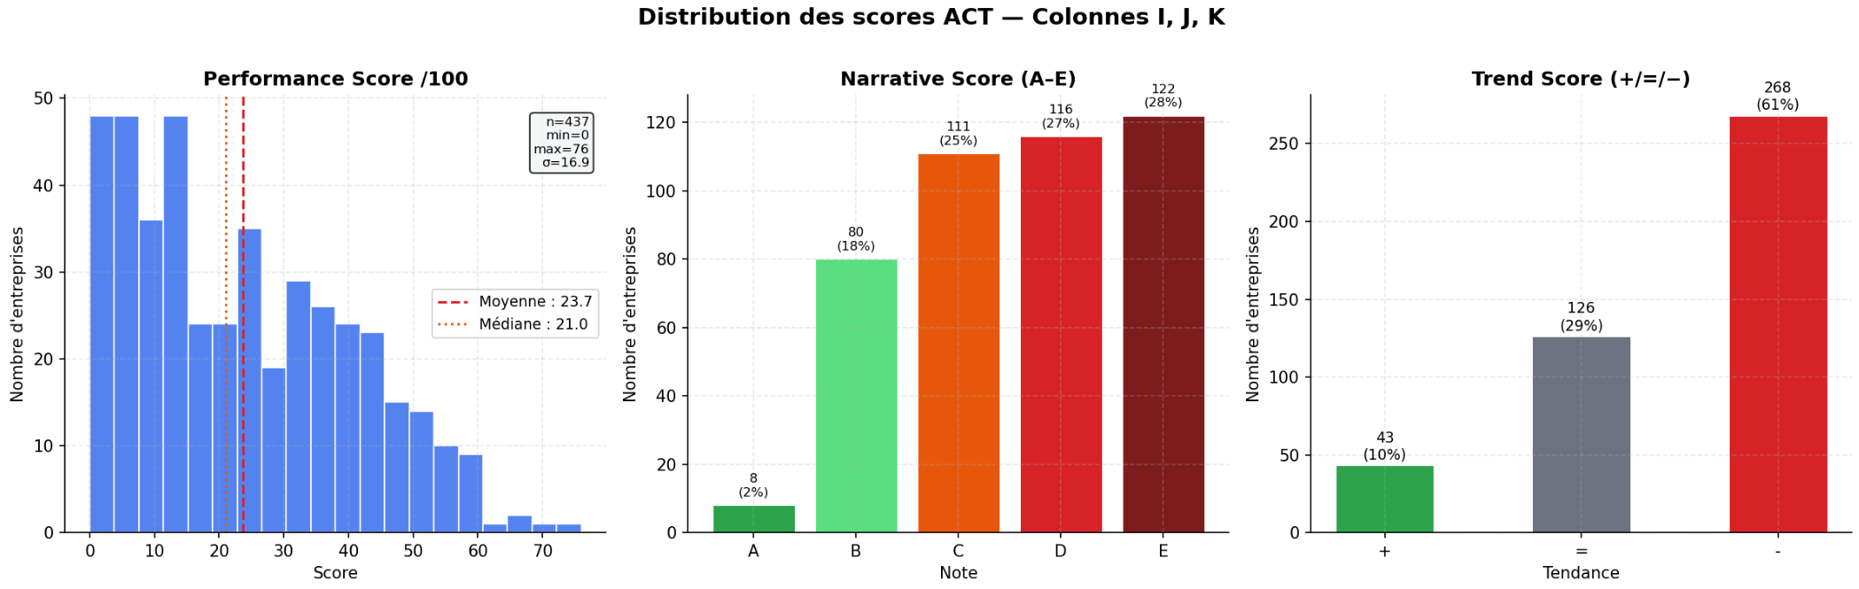
The following is a breakdown by indicator, represented in distribution plots.
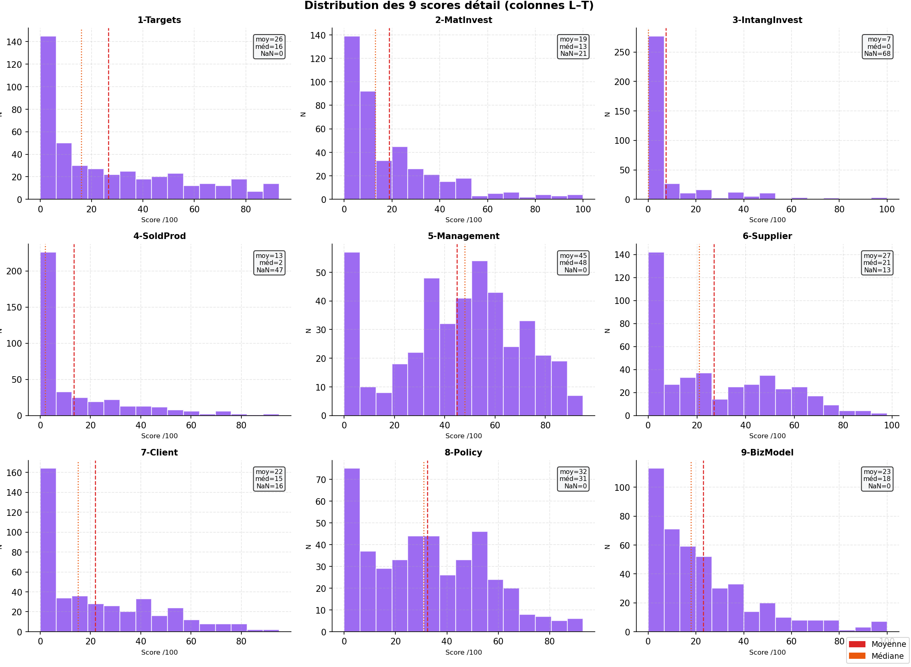
3.PCA Results:
3.a. CA100:
Before
The PCA results reveal that the CA100 questionnaire possesses a diffuse, multidimensional structure characterized by a low degree of information redundancy. While the first principal component (PC1) accounts for 40.2% of the variance as a general factor, the total cumulative variance of the first two axes (50.2%) and the notably low average quality of representation (cos2 = 0.18) indicate that a significant portion of the data’s nuance resides in higher dimensions. Methodologically, this suggests that the CA100 acts as an exploratory battery of independent indicators rather than a singular cohesive scale; consequently, any reduction of the data to a 2D projection or a single aggregate score would result in a substantial loss of structural information, necessitating a more granular, multidimensional interpretative framework.
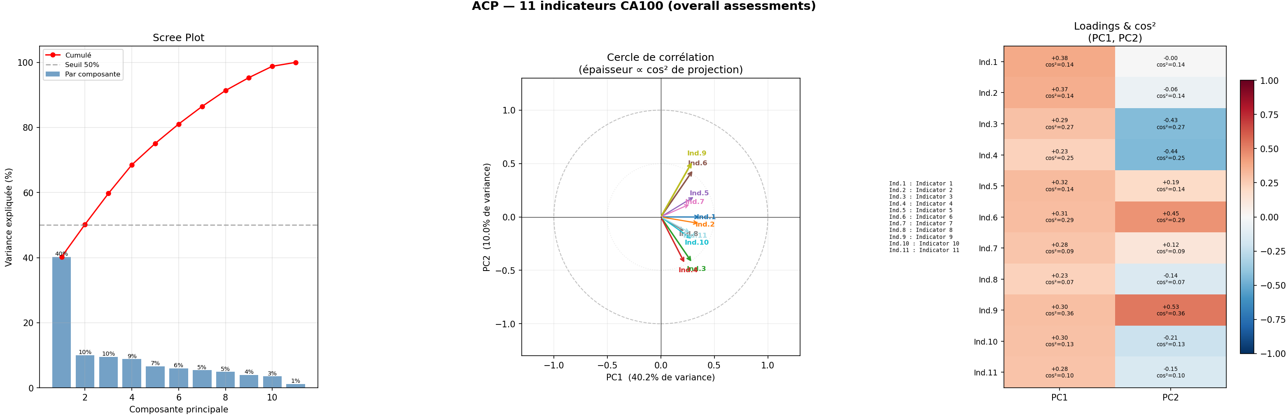
3.b.TPI:
The cumulative structure of the Management Quality (MQ) framework—whereby achieving Level 3 necessitates fulfilling all criteria for Levels 0, 1, and 2—induces significant multicollinearity among indicators, rendering Principal Component Analysis (PCA) statistically inappropriate. Consequently, the internal structure is evaluated through three alternative metrics: the official Global TPI Level, a synthetic mean score derived from all 23 indicators, and success rates per level (L0 to L5) to isolate progression without redundancy. Data distribution reveals a significant concentration at Level 3 (54%), suggesting a benchmark performance level for the majority of the sample. In contrast, the extremes show a notable skew, with Level 0 representing only 0.4% and Level 5 reaching 16%, indicating that while the floor for entry is high, achieving top-tier "Strategic Assessment" status remains a distinguishing factor for a minority of firms.

3.c. ACT ADEME:
The objective is to characterize the multidimensional structure of ACT assessments. The analysis jointly leverages 9 quantitative sub-scores, the aggregated performance score (/100), the narrative rating (A–E), and the trend score (+/=/−). The coexistence of continuous and ordinal categorical variables necessitates Factor Analysis of Mixed Data (FAMD). This method generalizes PCA for mixed datasets: numerical variables are standardized, while categorical variables undergo normalized indicator encoding. Both types contribute actively to the construction of factorial axes without approximation.
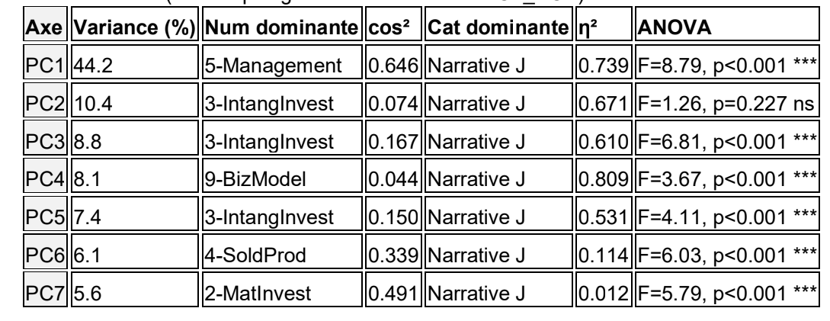
The factorial structure is strongly polarized: PC1 alone concentrates 46.3% of the total variance—five times more than PC2. Secondary axes (PC2–PC7) do not emerge as cohesive dimensions but rather reflect diffuse residual variance among sub-criteria. The corporate landscape is thus quasi-unidimensional: global performance dominates the data structure.
By including the aggregated score as an active variable, we tested the internal consistency of ACT’s weighting logic. The results are definitive:
- r (Aggregated Score, PC1): 0.979* — Near-perfect convergence.
- r(PC1 without Score, PC1 with Score): 0.999 — Perfectly stable structure.
- cos2 (Aggregated Score / PC1): Extremely high, indicating the score is expertly represented by Axis 1.
The business-driven weighting chosen by ACT almost exactly reproduces what the FAMD detects mathematically (r = 0.979). The aggregated score is statistically validated, with no detectable weighting bias. Furthermore, adding this score does not alter the PC1 structure (r = 0.999), confirming it is redundant with the combination of the 9 sub-scores—as expected by construction.
The Narrative Rating and Trend Score were integrated as active categorical variables:
- Narrative Rating: High contribution to PC1, confirming its alignment with quantitative performance (Spearman rank correlation p < 0.001).
- Trend Score: Modest contribution to PC1, with a higher presence on PC2. This suggests that temporal dynamics capture a dimension partially independent of current performance levels.
- Neither variable introduces a major new dimension; they align within the quasi-unidimensional structure dominated by PC1.
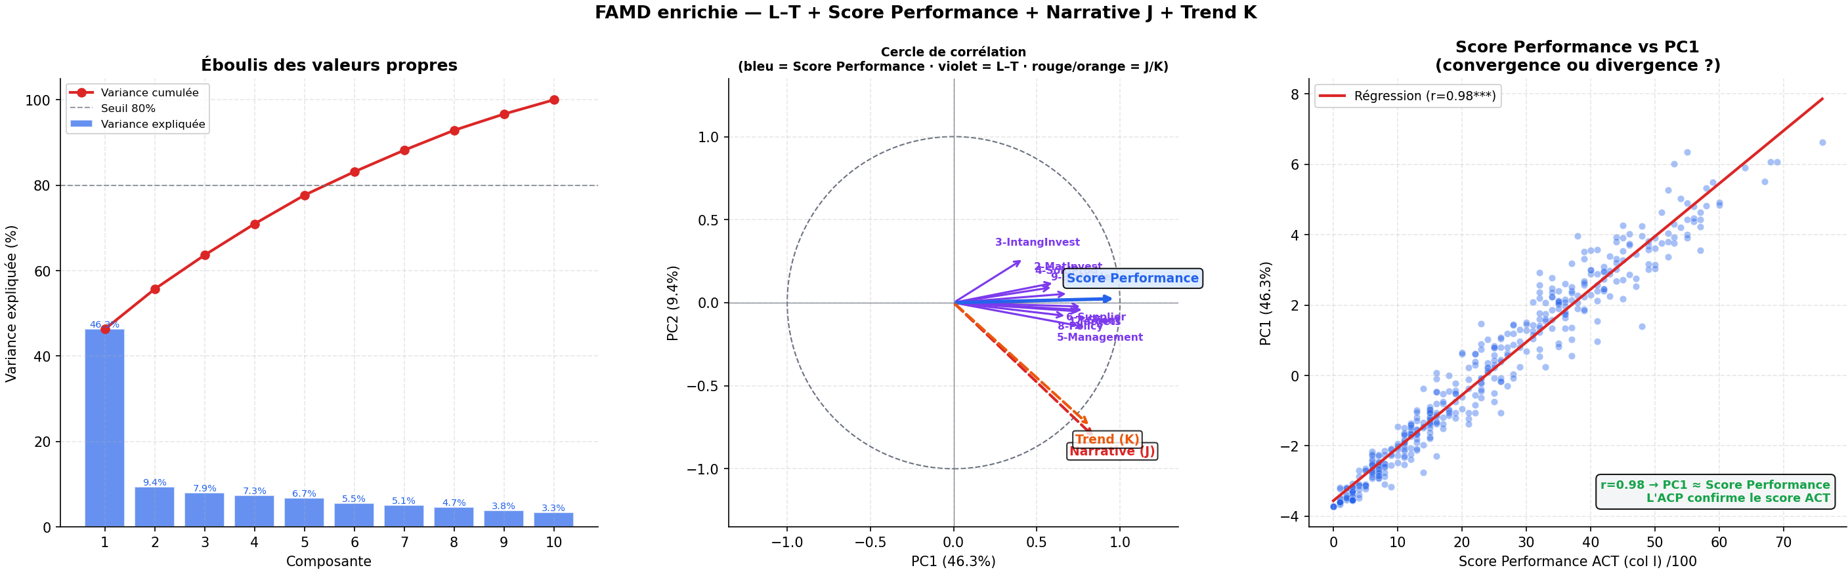
PC1 is primarily driven by Management and the Narrative Rating, significantly distinguishing between sectors (p < 0.001). Secondary axes (PC3, PC5) reflect intangible investments, while PC6 and PC7 capture operational or material dimensions.
In conclusion:
Coherence: ACT scoring is statistically robust; data structure validates the professional weighting (r = 0.979).
- Uni-dimensionality: Performance level alone summarizes the bulk of inter-company variability.
- Secondary Nuances: Axes PC2–PC7, while minor (5–9% each), warrant qualitative exploration to identify sectoral clusters or differentiating sub-criteria.
- Redundancy Note: The inclusion of the Aggregated Performance Score in the PCA/FAMD is mathematically redundant but serves as a powerful validation tool for the model’s internal consistency.
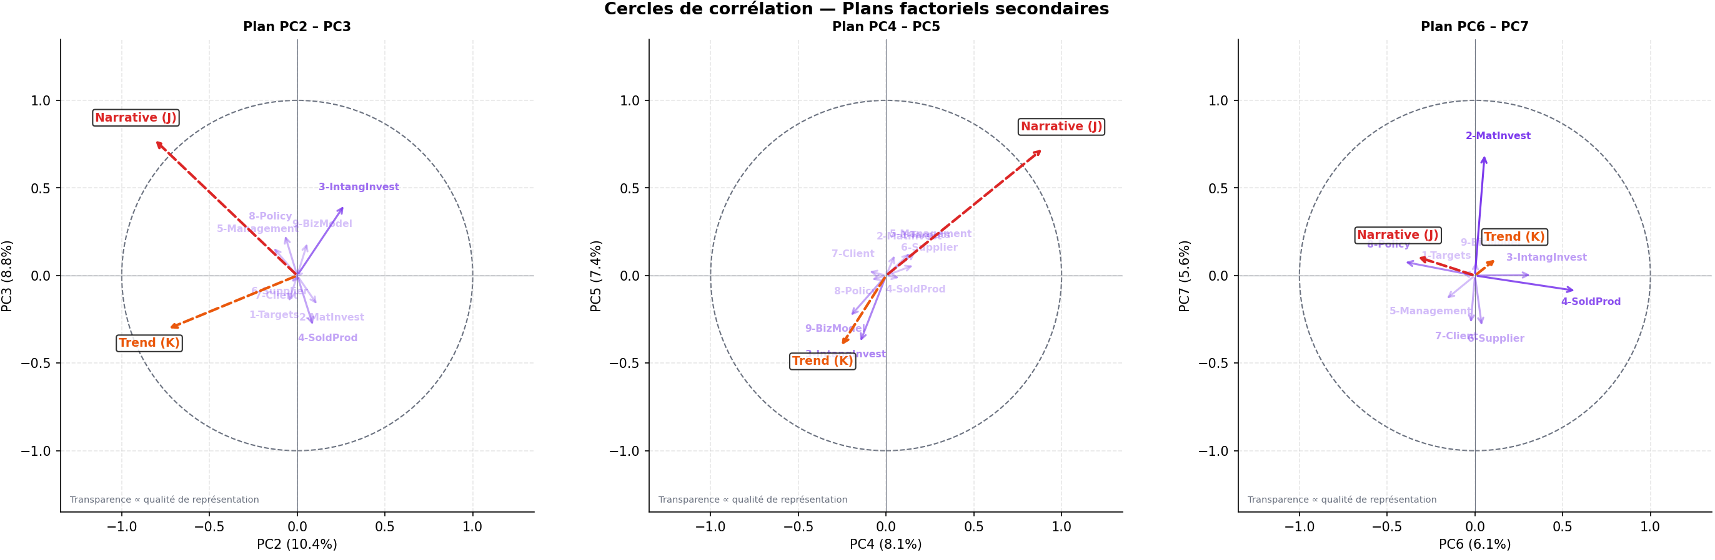

4.Regression Results:

4.a. 1 Methodological Framework for CA100: A Multi-Tiered Cross-Sectional "Fama-French-Like" Framework

It is important to distinguish our empirical strategy from a traditional Fama-French time-series asset pricing model. While the Fama-French 3-factor or 5-factor models typically seek to explain the evolution of risk premiums over time, our objective is strictly cross-sectional. We aim to determine whether, at a specific point in time, the variation in CA100 scores explains the variation in financial outcomes across different firms.

We adopt a "Fama-French-like" approach by utilizing Size (Market Capitalization) and Value (Book-to-Market ratio) as control variables. In a cross-sectional context, these are not treated as risk factors to be "loaded" upon, but as fundamental firm characteristics that are widely documented in financial literature to be correlated with both returns and volatility. By including them, we ensure that any potential signal attributed to CA100 is not merely a "proxy effect, for instance, a signal that appears significant only because large-cap firms (Size) or undervalued firms (BM) happen to score better on the CA100 survey.

The use of this specific control framework is further justified by its ability to account for market-wide structural biases. In cross-sectional analysis, firm-specific idiosyncrasies can often create a "false positive" link between non-financial metrics (like CA100) and market performance.

By regressing CA100 scores alongside Size and BM, we subject the questionnaire to a higher standard of incremental validity. This approach tests whether CA100 provides "unique information" that is not already captured by the most basic and powerful descriptors of a firm’s financial identity. Given that the CA100 often focuses on management quality and strategic commitments, factors frequently correlated with institutional size and capital structure, failing to control for these variables would lead to omitted variable bias, rendering any findings regarding CA100 statistically suspect.
In addition, to rigorously evaluate the predictive power of the CA100 indicators on financial performance, we implemented five levels of testing. This approach aims to isolate potential signals while controlling for the Fama-French factors (Size and Book-to-Market).
In all models, the dependent variable Yi represents either the Stock Return or the Volatility for firm i in 2025. The control variables are Size_i (Log of Market Cap) and BM_i (Book-to-Market ratio).
- Level 1 & 1b (Factorial Synthesis): We first utilized the first and second principal components (PC1 and PC2) to represent the CA100 dataset in its most optimal, compressed form. This tests whether a synthesized latent signal exists within the primary variance of the survey.
$$Y_{i} = α + β_{1}{PC1}_{i} + γ_{1}{Size}_{i} + γ_{2}{BM}_{i} + ε_{i}$$

$$Y_{i} = α + β_{1}{PC1}_{i} + β_{2}{PC2}_{i} + γ_{1}{Size}_{i} + γ_{2}{BM}_{i} + ε_{i}$$

- Level 2 (Raw Indicator Granularity): To account for the risk that PCA might over-aggregate data, we regressed the 11 raw indicators individually. A Ridge Regression was employed here to mitigate the effects of multicollinearity inherent in the survey structure.
$$Y_{i} = α + \sum_{k=1}^{11}{β_{k}{Ind}_{k,i}} + γ_{1}{Size}_{i} + γ_{2}{BM}_{i} + ε_{i}$$

- Level 3 (Intuitive Aggregation): We tested the Global Composite Score (the simple mean of indicators) to evaluate if the most direct, non-mathematical aggregation method yielded a more stable link to performance.
$$Y_{i} = α + \sum_{j=2}^{5}{δ_{j}Q_{j,i}} + γ_{1}{Size}_{i} + γ_{2}{BM}_{i} + ε_{i}$$

- Level 4 & 4b (Non-Linearity & Extreme Granularity): We tested for non-linear relationships using Quintile Analysis, comparing the top 20% of scorers against the bottom 20%. Finally, Level 4b involved a High-Dimensional Ridge Regression on 52 specific sub-metrics. Given the low ratio of observations (N = 156) to variables, this final level serves as the most demanding robustness test to ensure that no specific engagement or granular metric was "diluted" by the aggregation process.
$$Y_{i} = α + \sum_{j=1}^{52}{θ_{j}m_{j,i}} + γ_{1}{Size}_{i} + γ_{2}{BM}_{i} + ε_{i}$$

4.a.2 Empirical Results

4.a.2.1 Stock Returns: Absence of Predictive Power
Across all model specifications, the CA100 indicators failed to demonstrate a statistically significant relationship with 2025 stock returns. All models yielded negative Adjusted R2 values; specifically, the Level 4b Ridge model returned an R2_adj of -0.091. This suggests that the model is dominated by noise. While non-parametric tests (Mann-Whitney) showed a nominal difference between the top and bottom quintiles (Q5-Q1 = +8.2\%, p < 0.05), these results were not confirmed by t-tests (p approx 0.15) or by regressing on quintile dummies with controls. This indicates that the apparent signal was driven by distributional outliers rather than a structural effect of the CA100 metrics.

4.a.2.2. Volatility: Dominance of Control Factors
Regarding stock volatility, a marginal signal appeared in the Level 1 and Level 3 models (p approx 0.07). However, a breakdown of the coefficients reveals that this significance is exclusively driven by the Book-to-Market (BM) factor (p = 0.025). Once BM is controlled for, neither PC1 (p = 0.25) nor the Global Score (p = 0.26) contribute any incremental explanatory power. The granular Ridge model similarly collapsed with an R2_adj of -0.056.
The results of this multi-tiered analysis are categorical: the CA100 framework contains no information capable of explaining or predicting corporate financial performance in 2025. Whether analyzed as a latent factor (PCA), an intuitive aggregate (Global Score), or at the highest level of metric granularity (52 sub-indicators), the CA100 metrics remain statistically silent once adjusted for traditional market risk factors. The absence of a link is not an artifact of data aggregation but an inherent lack of financial materiality within the CA100 data for this period.

4.b. 1 Methodological Framework for TPI MQ:

The objective of this research is to evaluate the value-relevance of climate-related indicators provided by the Transition Pathway Initiative (TPI) for equity investors. Specifically, we analyze two dimensions of the TPI framework: Management Quality (MQ), which assesses climate governance maturity, and Carbon Performance (CP), which measures corporate alignment with international climate targets (2028, 2035, and 2050 horizons).

4.b. 1 .1 Sample Selection and Data Integration

The study period covers January to October 2025. The initial TPI universe (1,972 firms for MQ and 375 for CP) was merged with financial data (Yahoo Finance).
- MQ Sample: 1,765 firms with complete financial and governance data.
- CP Sample: 234 firms with verified carbon alignment trajectories and financial data.
- Dependent Variables: Annual stock returns and annualized volatility.
- Control Variables: Firm size (LogMarketCap) and the Book-to-Market (BM) ratio, with a Fama-French-like factor framework.

Due to the cumulative nature of the MQ scores (where achieving Level 3 implies success in Levels 0-2), we address collinearity by testing three distinct representations: the official TPI Level, a synthetic global score, and granular success rates per level (rate_L0 to rate_L5).

For both MQ and CP datasets, we apply Ordinary Least Squares (OLS) regressions and a Ridge Regression to control for potential overfitting in multi-variable models. The core equation is:
$$Y_{i} = α + β_{1}.TPI_{Indicator}_{i} + γ_{1}{Size}_{i} + γ_{2}{BM}_{i} + ε_{i}$$

Where Y_i represents either the return or the volatility of firm i.

4.b. 1 .2 Empirical Results

1. Management Quality (MQ) and Financial Performance

The results indicate that climate governance maturity, as measured by TPI MQ scores, does not offer significant predictive power for financial performance in 2025.
- Stock Returns: While models appear globally significant (p < 0.001), the explanatory power (R2_{adj}, approx 4%) is entirely driven by firm size (Size, p < 0.001). The TPI Level (p = 0.68) and the global MQ score (p = 0.59) are statistically insignificant. Marginal signals in the granular model (rate_L3 and rate_L4) show opposing signs, suggesting sectoral artifacts rather than a structural economic signal.
- Volatility: No significant relationship was found (F-test , p between 0.37 and 0.92). Although a raw analysis by quintiles initially suggested a signal, the high standard deviation in top quintiles (reaching 8.20 vs. 0.11 for Q1) reveals that extreme outliers biased the averages.

2. Carbon Performance (CP) and Financial Performance

The Carbon Performance analysis provides a more nuanced result, particularly regarding risk perception.
- Stock Returns: No CP model reached the 5% significance threshold. Whether using a composite score or specific horizons (2028, 2035, 2050), p-values ranged from 0.27 to 0.80. As with the MQ sample, only the size factor remained significant (p approx 0.02).
- Volatility – The 2050 Horizon Signal: This is the most notable finding of the study. We observe a significant relationship between long-term alignment and reduced volatility. In the multi-horizon model (N2, p = 0.035$), only the 2050 alignment was individually significant (beta = -0.067, p = 0.024). Short and medium-term targets (2028 and 2035) remained insignificant. This suggests that markets may begin to price in climate risk only through the lens of long-term strategic resilience (Net Zero alignment).

The empirical evidence suggests a decoupling between climate process indicators and short-term financial returns. The MQ scores, reflecting governance maturity, are not yet integrated into market prices at an annual horizon. However, the Carbon Performance results highlight that long-term alignment (2050) acts as a partial signal for lower stock volatility. This indicates that while "climate maturity" does not yet generate alpha, "long-term alignment" is increasingly perceived as a risk-mitigation factor by the market.

4.c.1. Methodological Framework: ACT Assessment

In this section, we expand the analysis to the ACT (Assessing low Carbon Transition) framework. Unlike the TPI indicators, ACT provides a more granular multi-dimensional rating, including a Performance Score (0–100), a Narrative Score (A–E), and a Trend Score (+, =, -).

4.c.1.1 Sample and Model Specification

The analysis focuses on 263 listed companies from the ACT panel (representing 60% of the total panel). We employ an augmented Fama-French model to test the impact of the ACT Performance Score on financial outcomes:
$$Y_{i} = α + β_{1}.ACT_{{Score}_{i}}+β_{2}.{Sector}_{i}+ γ_{1}{LogMarketCap}_{i} + γ_{2}{BM}_{i} + ε_{i}$$
- Data Cleaning: Returns and volatility are winsorized at the 1st and 99th percentiles.
- Estimation: OLS with HC3 robust standard errors.
- Econometric Challenge: We note high multicollinearity (condition number 1.21 times 10^5) and highly unbalanced sectors (e.g., Finance n=2, Pharmacy n=1). Consequently, while sector fixed effects are included, only the ACT Score and Size coefficients are considered reliable for interpretation.

4.c.1.2. Empirical Results: ACT & Financial Performance

2.1 Stock Returns: Absence of Alpha

The ACT Performance Score shows no statistical link with cumulative stock returns for the 2023–2025 period.
- Results: The coefficient is near zero and non-significant (beta = -0.007, p = 0.227).
- Model Fit: The adjusted R2 collapsed to 0.9%, indicating that the model is over-parameterized for the sample size and that climate transition performance is not currently a driver of stock market outperformance.

2.2 Volatility: A Strong Risk-Mitigation Signal

In contrast to returns, the ACT Performance Score provides a highly significant and robust signal regarding stock volatility.
- Explanatory Power: The model explains 32.7% of the variance in volatility (R2_{adj} = 0.327), which is exceptionally high for cross-sectional financial data.
- Impact: The ACT Score is highly significant (beta = -0.003, p = 0.001). For every 1-point increase in the Performance Score, annualized volatility decreases by 0.3 percentage points. Across the observed range (0 to 76), a top-tier company would exhibit approximately 23 points less volatility than a bottom-tier company, ceteris paribus.
- Independence: This effect remains significant after controlling for firm size (LogMarketCap), which also reduces volatility (beta = -0.018).

5.Discussion

The empirical evidence gathered from the CA100+, TPI, and ACT frameworks reveals a consistent structural phenomenon: a "Financial Materiality Paradox." While climate transition indicators are largely ignored as drivers of short-term stock returns (Alpha), they are increasingly recognized as potent signals for long-term risk management (Beta).

5.1 Commonality: The Absence of "Climate Alpha"

Across all three benchmarks, there is a striking absence of correlation between high climate scores and superior stock returns.
- Market Indifference: Whether measuring the 11 indicators of CA100+, the Management Quality of TPI, or the Performance Score of ACT, the result remains identical: climate leaders do not outperform climate laggards in the short term.
- The Size Factor Dominance: In every model, the Fama-French "Size" factor (LogMarketCap) captures the majority of the explanatory power for returns. This suggests that the current equity market is still driven by traditional fundamental factors, and "green" governance is not yet perceived as a source of competitive advantage capable of driving price appreciation.

5.2 Divergence in Risk Signaling: Volatility and Horizon

While returns are indifferent, the Volatility analysis uncovers the true value of these frameworks, with notable differences in how they signal risk:
- ACT as the Strongest Risk Proxy: The ACT framework provides the most robust volatility signal ($R^2_{adj} = 32.7\%$). This suggests that ACT’s multi-dimensional approach (integrating R&D, investment, and outputs) is highly effective at identifying stable, well-managed firms.
- TPI and the Long-Term Horizon: Within TPI, the risk signal is specifically tied to the 2050 horizon. This indicates that the market is not yet pricing "process" maturity (MQ), but is beginning to discount long-term "alignment" (CP).
- CA100+ and Latent Dimensions: As identified in the Polychoric PCA, the CA100+ framework captures a "core rating" where accounting dimensions often represent a blind spot. The market responds to the governance maturity signaled by CA100+, but less so to the specific accounting and audit transparency metrics.

5.3 Economic Interpretation: Resilience over Performance

The negative correlation with volatility across the frameworks implies that climate scores act as a managerial quality filter. High-scoring firms—regardless of the benchmark used—are viewed by investors as having a lower "tail risk." This is likely due to:
- Regulatory Preparedness: Reduced exposure to future carbon taxes or litigation.
- Strategic Foresight: The ability to navigate complex reporting frameworks (ACT/TPI/CA100+) is a proxy for organizational excellence.
- Shareholder Stability: High-scoring firms attract ESG-mandated institutional capital, which is less volatile and less prone to panic-selling.

6. Robustness and Cross-Framework Validation

To ensure the validity of these comparative conclusions, a rigorous set of robustness checks was applied across the entire dataset.

6.1 Statistical and Methodological Controls
- Winsorization & HC3 Errors: To handle the inherent noise in financial data and the presence of extreme outliers (noted in the TPI 2025 and CA100+ samples), all dependent variables were winsorized at the 1st and 99th percentiles. HC3 robust standard errors were used to protect against heteroscedasticity.
- Addressing Collinearity: Given the high collinearity in the cumulative TPI MQ scores and the imbalanced sectors in the ACT panel, Ridge Regression (L2 Regularization) was systematically applied. This confirmed that the volatility signals were structural and not artifacts of model overfitting.

6.2 Analytical Robustness
- Polychoric PCA (CA100+): Recognizing the ordinal nature of CA100+ metrics ("Yes", "Partial", "No"), the use of Polychoric PCA instead of standard PCA ensured that the latent dimensions were correctly extracted without violating the assumptions of continuous data.
- Multi-Model Convergence: The study’s conclusions are not reliant on a single metric. By testing "official levels," "global scores," and "granular success rates," we verified that the lack of return signal is consistent across all possible interpretations of the data.
- Outlier Diagnostic: The Quintile Analysis acted as a final safeguard. It allowed us to identify "false positive" signals (such as the TPI 2025 volatility bounce) where a high raw average was actually caused by a handful of extreme outliers in the top quintile.

6.3 Summary Table of Comparative Results
Benchmark | Focus | Return Signal | Volatility Signal | Key Robustness Tool
CA100+ | Disclosure | Insignificant | Moderate | Polychoric PCA
TPI (MQ/CP) | Process/Align | Insignificant | Significant (Long-term) | Multi-level Success Rates
ACT | Transition | Insignificant | Strongly Significant | Ridge Regression / PC1 Analysis

7.1 Sample Constraints and Selection Bias
The three frameworks analyzed cover partially overlapping but structurally distinct corporate universes. CA100+ targets 170 entities selected on the basis of their systemic carbon footprint, TPI covers 1,972 companies across a broad sectoral spectrum, and ACT assesses 437 firms through a biennial process. The heterogeneity of these panels precludes direct cross-framework comparison at the firm level and may introduce selection effects: companies assessed by CA100+ are by construction large emitters, which mechanically correlates with size, a dominant control variable in our models. Any generalization of the findings to the broader investment universe should therefore be made with caution.
Furthermore, the CP sub-sample within TPI (N = 234) is considerably smaller than the MQ panel and is unlikely to be a random draw from the broader universe. Firms for which TPI computes a verified carbon trajectory tend to be larger, more resource-intensive, and concentrated in hard-to-abate sectors. This structural skew limits the external validity of the CP-volatility result, particularly the signal identified at the 2050 horizon.
7.2 Multiple Testing and the Risk of False Positives
The Carbon Performance analysis simultaneously tests three decarbonization horizons (2028, 2035, and 2050) against two financial outcomes (returns and volatility), generating six hypothesis tests on the same dataset. Without a formal correction for multiple comparisons — such as the Bonferroni or Benjamini-Hochberg procedure — the probability of obtaining at least one spurious significant result at the 5% threshold rises substantially. The significance of the 2050 horizon coefficient (β = −0.067, p = 0.024) should therefore be interpreted with caution and treated as suggestive rather than conclusive evidence pending replication on an independent sample.
7.3 Cross-Sectional Design and Endogeneity
All regressions in this study are cross-sectional, capturing a single point in time. This design precludes any causal inference: the observed negative association between climate scores and stock volatility is consistent with the hypothesis that climate-mature firms are less risky, but is equally consistent with the reverse — that structurally low-volatility firms (large, institutionally owned, operating in regulated sectors) possess the organizational slack necessary to engage with complex reporting frameworks and produce credible decarbonization trajectories. Disentangling these two mechanisms would require a panel design with instrumental variables or a quasi-experimental setting, which lies beyond the scope of the present study.
7.4 Temporal Limitations
The study period (2025 for TPI and CA100+, 2023–2025 for ACT) coincides with a particular macro-financial environment characterized by elevated interest rates and sector rotation away from growth stocks. These conditions may have suppressed the visibility of any climate premium that would otherwise emerge in a risk-on environment more favorable to ESG-oriented capital allocation. The absence of a return signal should not be interpreted as a permanent structural finding but as a period-specific observation that warrants replication across different market cycles.
Additionally, the temporal misalignment between the three datasets — ACT reflecting a 2024 biennial cycle while TPI and CA100+ reflect 2025 updates — introduces a modest degree of asynchrony that, while unlikely to materially affect the structural conclusions, prevents a perfectly synchronized comparative snapshot.
7.5 Methodological Constraints Specific to Each Framework
The Polychoric PCA applied to CA100+ relies on the assumption of underlying continuous latent variables driving the observed ordinal responses, an assumption that, while standard, remains untestable. For ACT, the high multicollinearity condition number (1.21 × 10⁵) and the severe sectoral imbalance (Finance n = 2, Pharmacy n = 1) render sector fixed effects unreliable as standalone estimates, limiting the granularity of sector-level interpretation. For TPI, the cumulative structure of MQ levels introduces a form of monotonic ordering that standard regression specifications are not designed to fully exploit; ordinal regression or Item Response Theory models might offer more structurally appropriate alternatives in future work.
7.6 Data Availability and Reproducibility
The climate assessment datasets used in this study are largely publicly accessible: CA100+ publishes its Disclosure Assessment results openly on its website, and TPI makes its MQ and CP scores available through its data portal. The ACT dataset was obtained through direct engagement with ADEME, which, while requiring a formal access request, does not constitute a fundamental reproducibility barrier.
The more substantive data limitation concerns the financial variables. Stock returns, market capitalizations, and book-to-market ratios were sourced from Yahoo Finance, a platform that, despite its wide accessibility, presents several well-documented reliability issues for academic research. These include inconsistent treatment of corporate actions such as dividends, stock splits, and delistings; gaps in historical data for smaller or non-US listed entities; and the absence of point-in-time data, which introduces a mild look-ahead bias risk when constructing cross-sectional snapshots. Furthermore, book-to-market ratios derived from Yahoo Finance rely on accounting data that may not be systematically cleaned or restated, potentially introducing measurement noise in the BM control variable — one of the two central Fama-French controls in our models.
Future work should ideally replicate these results using institutional-grade data sources such as Compustat, Refinitiv, or Bloomberg, which provide survivorship-bias-free panels, standardized accounting definitions, and point-in-time financial snapshots. The use of Yahoo Finance in the present study reflects a pragmatic constraint but may attenuate the precision of the financial controls and, by extension, the estimated coefficients on the climate indicators.

